PWM_CLASS program output:

1. For 10% duty cycle.

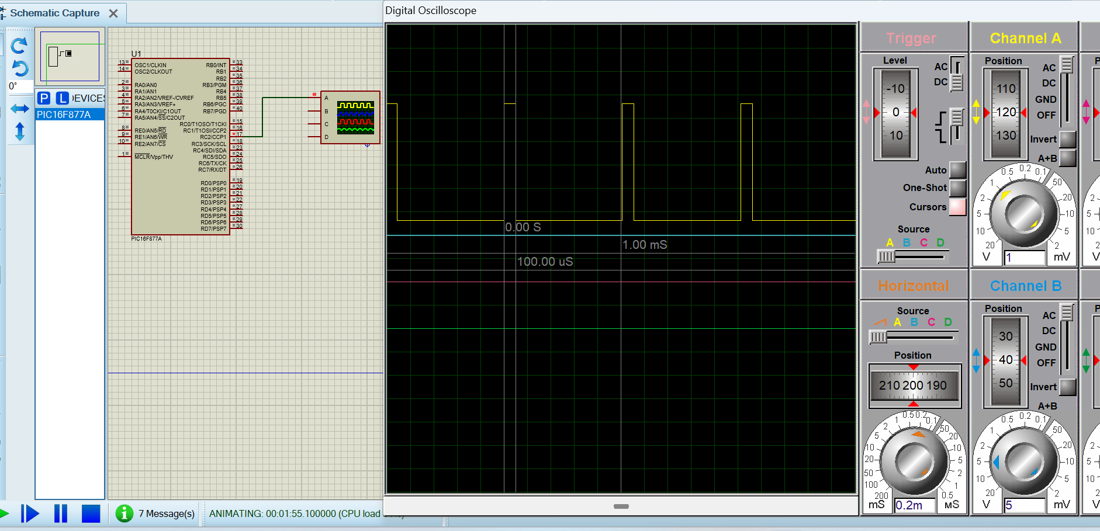

1. For 50% duty cycle.

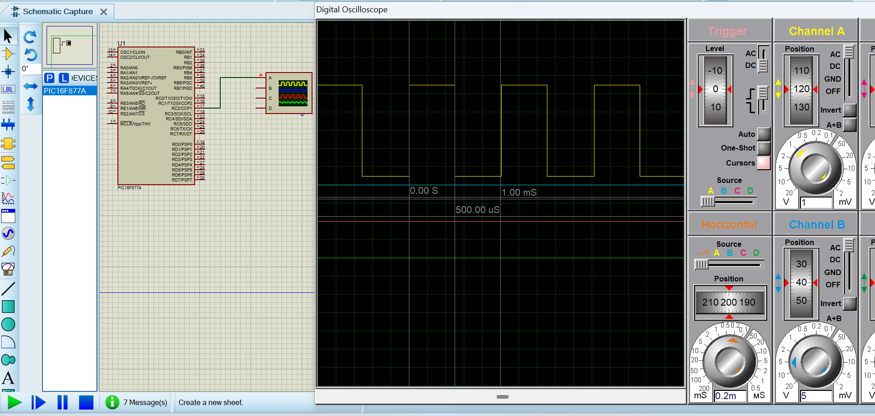

1. For 80% duty cycle

